Qoo10 New Product Listing

Go to Listing&Editing

Press “search” to show the products already listed

Press “new item listing” to list a new product

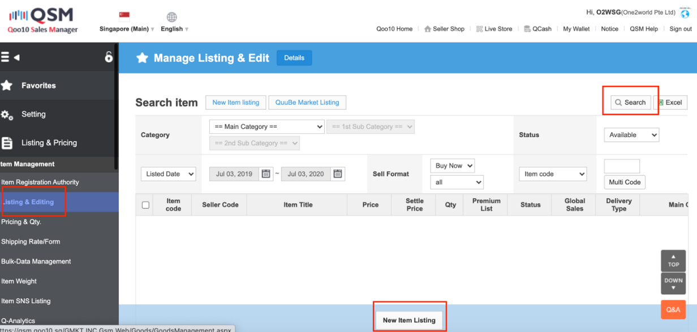

Below highlighted in yellow items can be considered as one listing, because it is same model difference size. But take note the price is different for iphone 11 Pro and 11 Pro Max

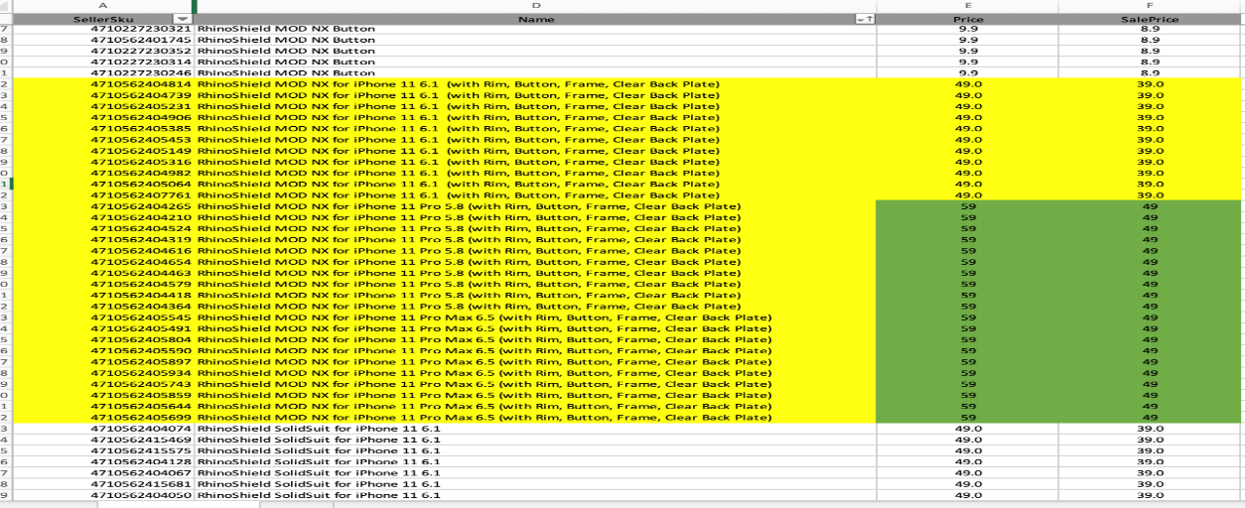

Choose correct category, item title copy from the product list, here we use “iPhone 11 Series” to replace the 3 sizes or you can use ★ to represent each model

The rest setting follow below screen shot

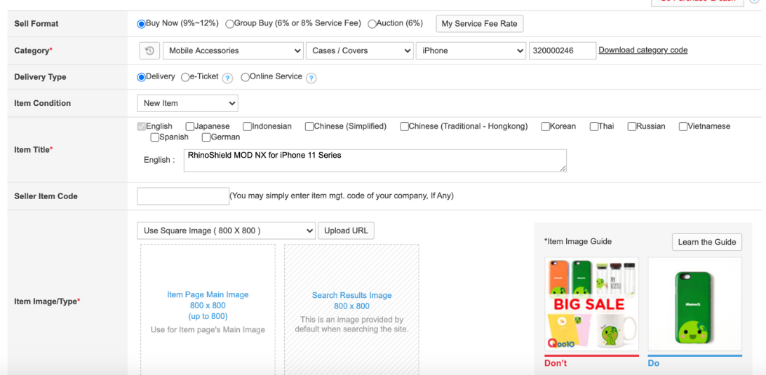

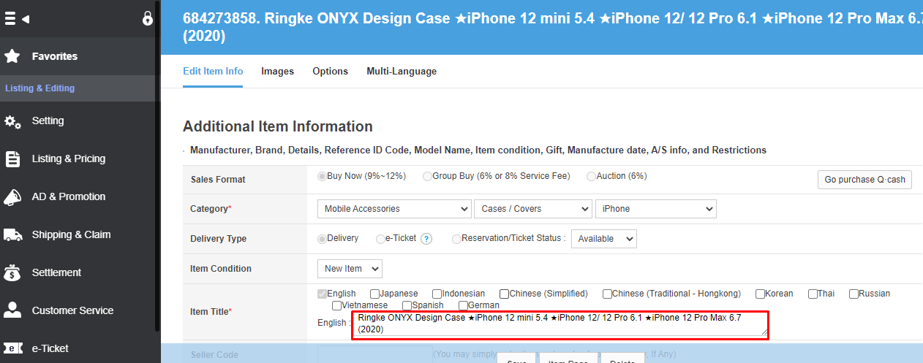

Item image upload a group image to best represent our product, normally is white background.

Sell price and retail price follow the product list, take note if the price is different for different sizes or colours, here always put the lowest price.  
The qty total combined all QTY in put in the Available total Qty Unit.

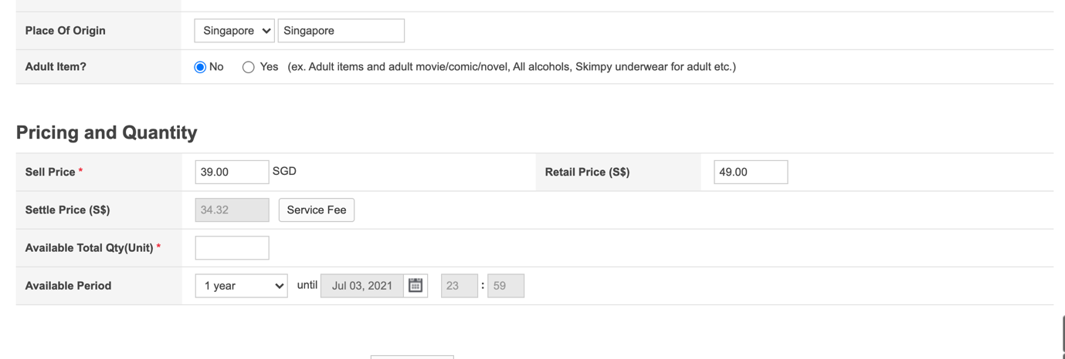

Shipping information is always 0.6 follow below screen shot.

Always Choose Qprime-S Shipping

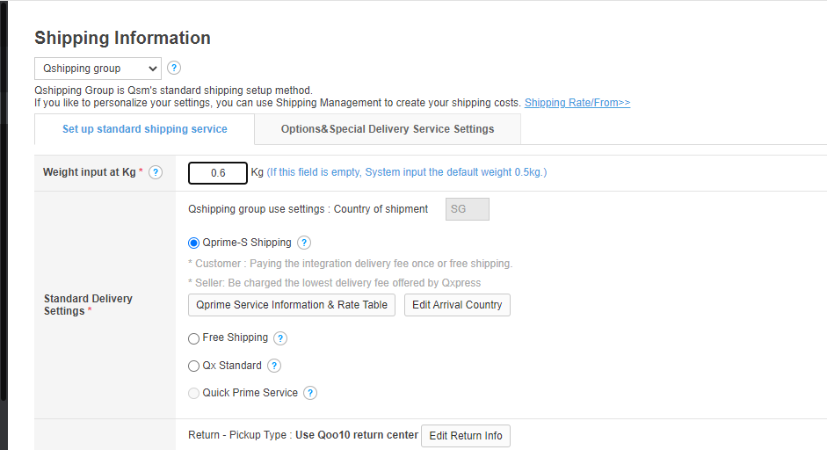

Item Description copy from official website or Amazon or in the lazada website, just copy paste the description, and Put lifestyle Images

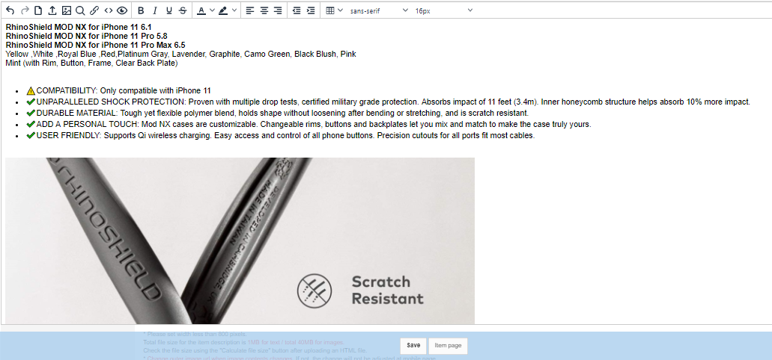

We use item options to add in all the different sizes and colours.

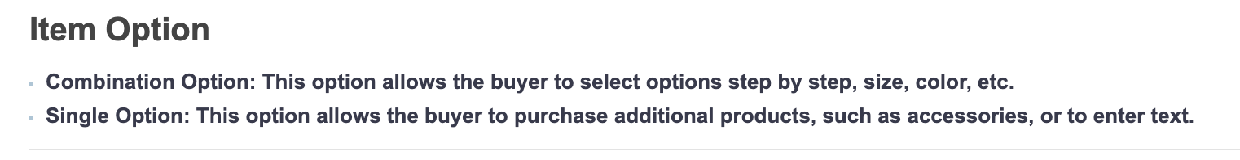

Choose make combination (2 Level or 3 Level depends on how many products to group together)

Option Name Choose “Direct Input”, and type in the name below, depends on the product to be listed, here we set Level 1 as “Device Model”, and Level 2 as “Colour”

Input the Options one by one, use comma to separate different options.

After that press “Generate Combination Option”

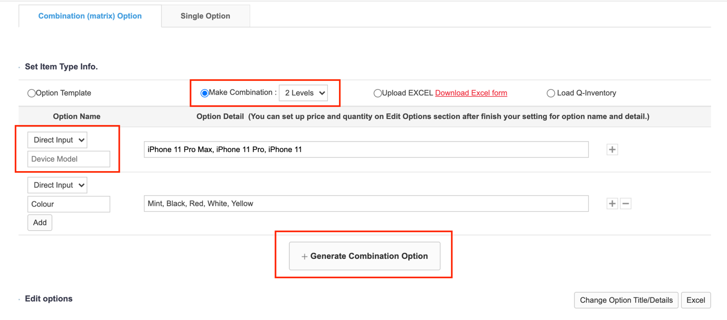

All the options will be shown below

Double click the seller option code cell to enter the UPC code for each variation.

The option price column is for you to set the price difference for each variations, for example the product list we have seen earlier in the guide, iPhone 11 6.1” is selling at $39, but iPhone 11 Pro 5.8” and iPhone 11 Pro Max 6.5” is selling at $49. And we have said to use the lowest price which is 39 at the earlier stage, as a base price.

Here we can use option price to make up the price difference, so for iPhone 11 Pro 5.8” and iPhone 11 Pro Max 6.5”, we input option price as $10 ($49 minus $39).

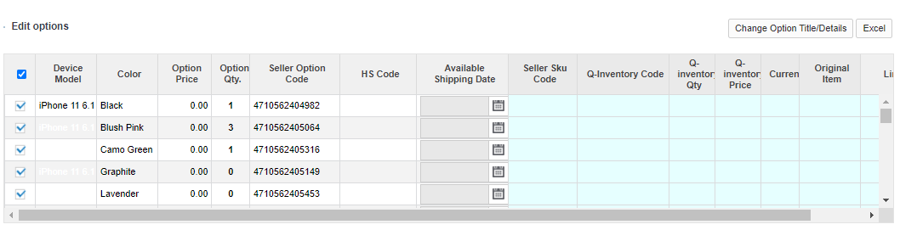

You can delete or add individual variations, for example if White colour is only available for iPhone 11 Pro and iPhone 11 Pro Max, you should delete white colour for iPhone 11. click the variation you want to delete and press delete button below.

If you want to add a variation, input all the information at the bottom, and press ADD.

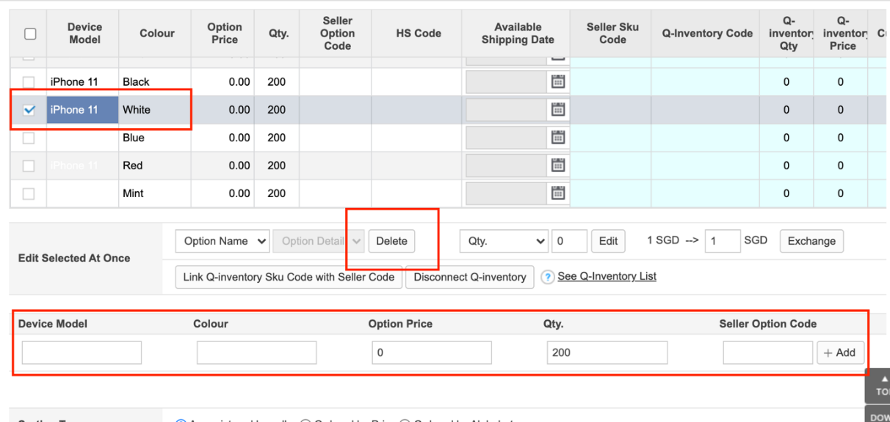

Sorting type – Ordered by Alphabet

The rest setting follow below screen shot, the press set image to add image for individual variations.

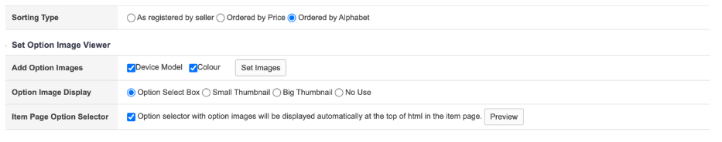

After all fill in, click save there is some pop up information but just click OK



And you will go to the Overview of the product

Here put the Brand name, Rhinoshiel,Zeelot,Zeetec, Etc. and Click Save do not forget to save every time when you have changes.

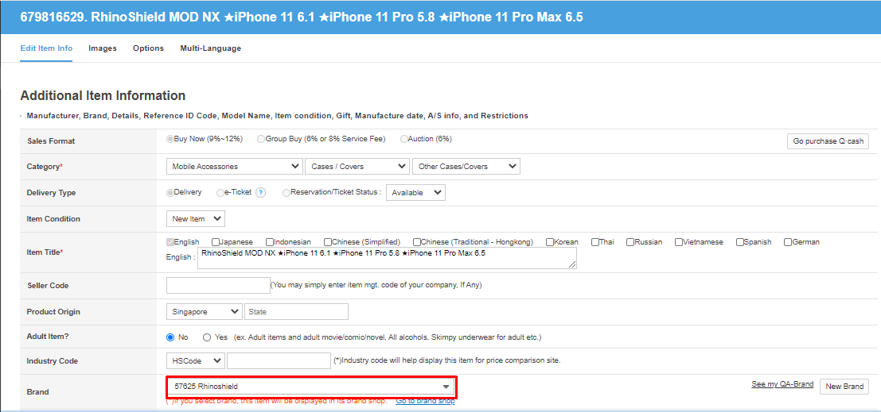

Second, Click the Image Option

Put all the second images accordingly there great look positions. Click save

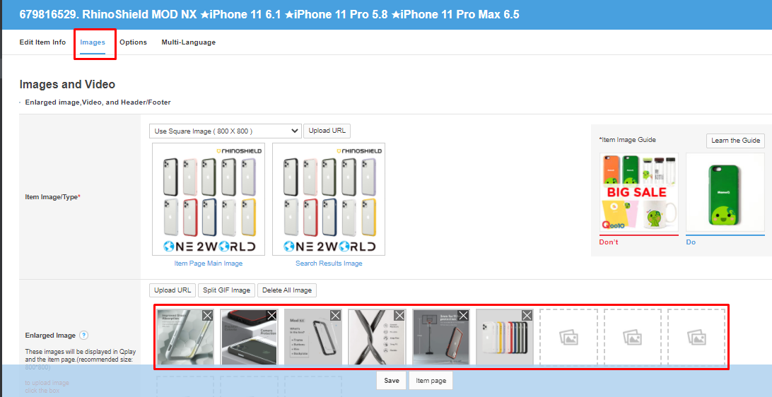

3rd options  
Click Set images

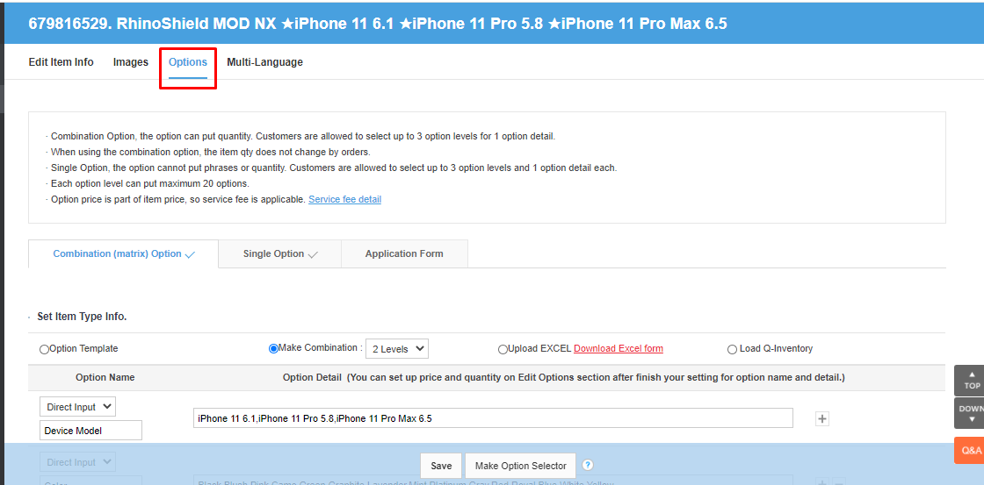

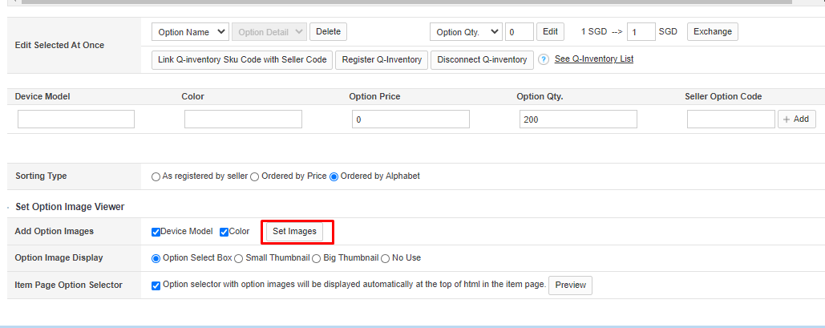

Here make sure that you put all variations images with logo frame of store.

Click close and Save,

And go back to Edit Item Info and select item page, here you can see the overview of the product that you list.   
For example this product https://www.qoo10.sg/GMKT.INC/Goods/Goods.aspx?goodscode=686558713

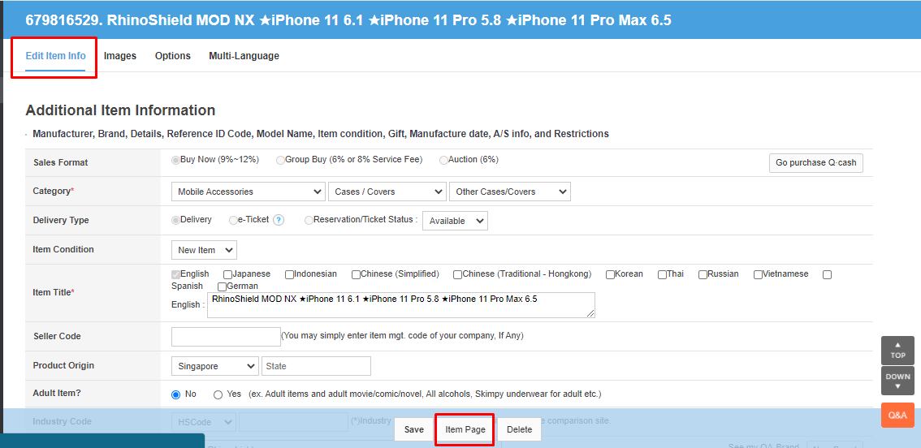

Make Sure you fill in this images

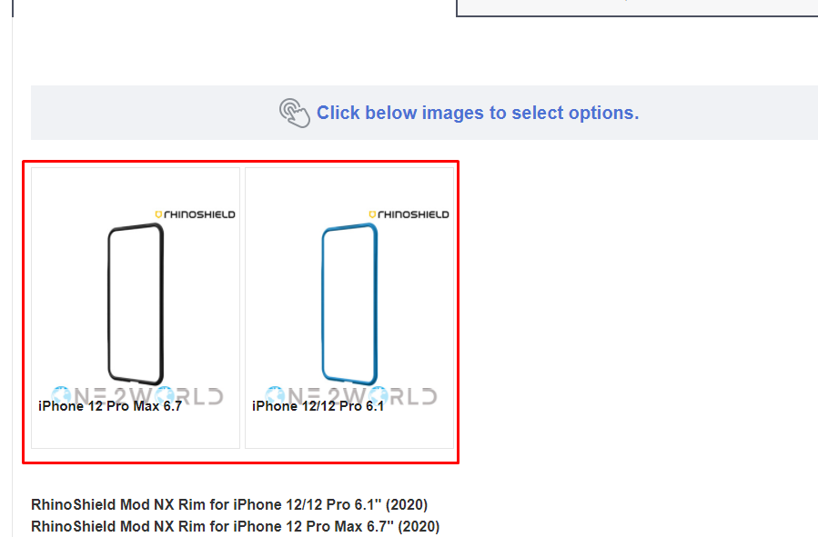

That’s all

Happy listing team 😊

For Zeelot LOCA Glass, put below installation guide into product description

Installation is very important to enjoy Zeelot product.

⚠️ MUST WATCH INSTALLATION VIDEO ⚠️ -

The short one-minute installation video promises a super easy, frustration-free, and bubble-free installation.

Check below the link :https://www.youtube.com/watch?v=AS5Bs9BSpF0

1.Before installation

- Remove any pre-installed screen protectors

- Remove any registered fingerprints that are on the phone

- Increase touch sensitivity to max

- Settle your phone on a stable and balanced surface.

- Take out the tool kit which includes wet wipe, cloth, dust remover, glue resistant sticker and Zeelot UV Glue.

2. Preparation:

- Use the "wet wipe" to clean your phone screen carefully.

- Use the "cloth" to dry-clean your screen again.

- Use large dust remover to make sure there is no more dust left on the surface.

- Take small glue resistant stickers to cover top speaker, charging & bottom speaker holes and buttons against UV Glue Flowing.

3. Working on it:

- Open the cap of UV Glue then pour it on the screen surface (follow the position as being shown in this video)

- Remove the back of screen guard.

- Put on the glass horizontally and slowly to avoid creating bubbles.

- Make sure the position fit nicely on the screen until the glue spreads out all over the screen.

- Use the cloth to absorb those extra glue coming out from the glass (if have) carefully.

- Use the UV Light to fix the glass on the screen for 60 seconds (top, middle, and bottom)

4. Finish

- Peel off the glue resistant stickers

- Re-register fingerprint for the best experience and sensitivity

- Enjoy Zeelot protection on your phone.

For NOMAD, add this into product description

The Horween Leather used on our products is a natural material that is expected to change in color and texture as a unique 'patina' is developed over time. Patina refers to how leather ages over time as the leather absorbs oils and is handled. We try our best to keep the Horween products in pristine condition until they arrive with the end customer. So, when the soft leather is first being used and scratches or marks appear, they may seem unwanted and not preferred. However, Nomad products are known for the patina process that enhances the leather with unique character specific to each customer. Most scratches to the surface of the leather will be buffed out in a few days naturally handling the product or you may expedite the patina process by rubbing some leather conditioner on the leather's surface.

The products are meant for daily use so that the oils from your hands are continuously buffing out the leather and enhancing the patina. However, if the case comes into contact with abrasive or harsh materials, just like any natural leather item, the leather may be damaged too deep to buff out back to a smooth texture. This would be considered cosmetic wear and tear.